Chapter-3

Job Attitudes

**Attitudes** are judgments or evaluative statements-either favorable or unfavorable-about objects, people, or events.

-They reflect how we feel about something.

Psychologists define attitudes as a learned tendency to evaluate things in a certain way. This can include evaluations of people, issues, objects, or events. Such evaluations are often positive or negative, but they can also be uncertain at times

### 3 Components of Attitude

* **Cognitive Component:** Your thoughts and beliefs about the subject
* **Affective Component:** How the object, person, issue, or event makes you feel
* **Behavioral Component:** How attitude influences your behavior

A figure shows the three components of attitudes: cognitive component, affective component and behavioral component and are closely related to each other.
Long description is available in notes, press F6

## Attitude Formation

Several factors can influence how and why attitudes form, including:

### Experience

Attitudes form directly as a result of experience. They may emerge due to direct personal experience, or they may result from observation.

### Social Factors

Social roles and social norms can have a strong influence on attitudes. Social roles relate to how people are expected to behave in a particular role or context. Social norms involve society's rules for what behaviors are considered appropriate.

### Learning

Attitudes can be learned in a variety of ways. Consider how advertisers use [classical conditioning](https://www.verywellmind.com/classical-conditioning-2794859)(a learning process that occurs when two [stimuli](https://www.google.com/search?client=firefox-b-d&sca_esv=5e1cf30a8e60a482&sxsrf=ACQVn0_0ywYyp5feHJwGZsaZMOrW2ocCjA:1709885823651&q=stimuli&si=AKbGX_r0zqXEeLlZhGfi3fbO0QSWQOKjF_CVFnGaIrkfRcZpzp_kGBYtEArf4rSTJNU7cfZRDWmWkipn8vOAjtLWutzXnPp_YA==&expnd=1) are repeatedly paired: a response which is at first [elicited](https://www.google.com/search?client=firefox-b-d&sca_esv=5e1cf30a8e60a482&sxsrf=ACQVn0_0ywYyp5feHJwGZsaZMOrW2ocCjA:1709885823651&q=elicited&si=AKbGX_q870E3DK3nJ7cu3BOD7pxC5Ctu88e7TR_rDobXZSD2zW_a7jMc3cZEi5wT1Pnqjn5sQrCP-UUWMpruXweX_INXaR-_oUt86ndthWH4YYXSymj20Ug=&expnd=1) by the second [stimulus](https://www.google.com/search?client=firefox-b-d&sca_esv=5e1cf30a8e60a482&sxsrf=ACQVn0_0ywYyp5feHJwGZsaZMOrW2ocCjA:1709885823651&q=stimulus&si=AKbGX_q870E3DK3nJ7cu3BOD7pxCE7fmK1SsBDgUeL6vVnsbzSAi5IKq_KowNJrQ2qLizUXT6U9H0zWmbAH4yPwohNPK0xYtl3GMM7L07V7JKVKKO-mCCzk=&expnd=1) is eventually elicited by the first stimulus alone - bell +food+dog) to influence your attitude toward a particular product. In a television commercial, you see young, beautiful people having fun on a tropical beach while enjoying a sports drink. This attractive and appealing imagery causes you to develop a positive association with this particular beverage.

### Conditioning

[Operant conditioning](https://www.verywellmind.com/operant-conditioning-a2-2794863) can also be used to influence how attitudes develop. Imagine a young man who has just started smoking. Whenever he lights up a cigarette, people complain, chastise him, and ask him to leave their vicinity. This negative feedback from those around him eventually causes him to develop an unfavorable opinion of smoking and he decides to give up the habit.

### Observation

Finally, people also learn attitudes by [observing people](https://www.verywellmind.com/what-is-observational-learning-2795402) around them. When someone you admire greatly espouses a particular attitude, you are more likely to develop the same beliefs. For example, children spend a great deal of time observing the attitudes of their parents and usually begin to demonstrate similar outlooks.

**Relationship between Attitudes and Behaviour**

The relationship between attitudes and behavior is a central concept in psychology and social sciences. Attitudes are individuals' evaluations, feelings, and beliefs about people, objects, or events, while behavior refers to the actions or reactions of individuals in response to stimuli. Understanding how attitudes influence behavior is crucial for predicting and explaining human actions. Several theories and models explain the relationship between attitudes and behavior:

**Theory of Planned Behavior (TPB):** According to TPB, behavior is determined by three factors: attitudes toward the behavior, subjective norms (perceived social pressure to perform or not perform the behavior), and perceived behavioral control (perceived ease or difficulty of performing the behavior). Attitudes significantly influence behavioral intentions, which, in turn, predict actual behavior.

**Attitude-Behavior Consistency:** This concept suggests that attitudes are often predictive of behavior when certain conditions are met, such as the attitude being strong, specific to the behavior in question, and accessible at the time of decision-making. When these conditions are present, individuals are more likely to act in accordance with their attitudes.

**Cognitive Dissonance Theory:** Cognitive dissonance occurs when individuals experience discomfort due to inconsistencies between their attitudes and behavior. To reduce this discomfort, individuals may change their attitudes to align with their behavior or change their behavior to align with their attitudes.

**Self-Perception Theory:** This theory proposes that individuals infer their attitudes from observing their own behavior. When there is ambiguity about one's attitudes, individuals may look to their own actions to determine their attitudes.

**Behavioral Confirmation:** This occurs when individuals' expectations about others' attitudes influence their behavior toward those individuals, which, in turn, elicits responses that confirm the original expectations. This highlights how attitudes can shape behavior not only in oneself but also in others.

Cognitive Dissonance

**What Is Cognitive Dissonance?**

*The attitudes that people hold determine what they do.

-Cognitive dissonance is any incompatibility an individual might perceive

between two or more attitudes or between behavior and attitudes.

*Research has generally concluded that people seek consistency among their

attitudes and between their attitudes and their behavior.

Cognitive dissonance is the mental discomfort that results from holding two

conflicting beliefs, values, or attitudes. People tend to seek consistency in their

attitudes and perceptions, so this conflict causes unpleasant feelings of unease or

discomfort

**Signs of Cognitive Dissonance**

• Feeling uncomfortable before doing something or making a decision

• Trying to justify or rationalize a decision you've made or action you have taken

• Feeling embarrassed or ashamed about something you've done and trying to hide your

actions from other people

• Experiencing guilt or regret about something you've done in the past

• Doing things because of social pressure or a fear of missing out (FOMO), even if it wasn't

something you wanted to do

**Examples of Cognitive Dissonance**

• You want to be healthy, but you don't exercise regularly or eat a nutritious diet. You feel guilty as a result.

• You know that smoking (or drinking too much) is harmful to your health, but you do it anyway. You rationalize this action by pointing to your high stress levels.

• You'd like to build up your savings but tend to spend extra cash as soon as you get it. You regret this decision later, such as when facing an unexpected expense that you don't have the money to cover.

• You have a long to-do list but spend the day watching your favorite shows instead. You don't want your spouse to know, so you try to make it look like you've worked hard all day.

**Causes of Cognitive Dissonance**

* Forced Compliance
* New Information
* Decisions

**\*Cognitive dissonance can often have a powerful influence on our**

**behaviors and actions. It doesn't just influence how you feel; it**

**also motivates you to take action to reduce feelings of discomfort.**

**How Cognitive Dissonance Feels**

• Anxiety

• Embarrassment

• Regret

• Sadness

• Shame

• Stress

**Impact of Cognitive Dissonance**

Because people want to avoid discomfort, cognitive dissonance can have a wide range

of effects. Dissonance can play a role in how we act, think, and make decisions. We

may engage in behaviors or adopt attitudes to help relieve the discomfort caused by

the conflict.

Some things that a person might do to cope with these feelings include:

• **Adopting beliefs or ideas to help justify or explain away the conflict** between their beliefs

or behaviors. This can sometimes involve blaming other people or outside factors.

• **Hiding beliefs or behaviors from other people**. People may feel ashamed of their conflicting

beliefs and behaviors, hiding the disparity from others to minimize feelings of shame and

guilt.

• **Only seeking out information that confirms existing beliefs**. This phenomenon, known as

confirmation bias, affects the ability to think critically about a situation but helps minimize

feelings of dissonance.

A **moderating variable** is a type of variable that affects the relationship between a [dependent variable](https://www.statology.org/independent-vs-dependent-variables/" \t "https://www.statology.org/moderating-variable/_blank)(Behaviour) and an [independent variable](https://www.statology.org/independent-vs-dependent-variables/" \t "https://www.statology.org/moderating-variable/_blank)(Attitude).

**Moderating Variables for Attitude-Behaviour relation:**

* Attitude’s importance
* Correspondence to behavior
* Accessibility
* Presence of social pressures
* Whether a person has direct experience with the attitude

*The attitude-behavior relationship is likely to be much stronger if an attitude refers to something with which we have direct personal experience

Job Attitudes

**Organizational Identification**

The extent to which employees define themselves by the same characteristics that define their organization.It is the degree to which employees define themselves as a member of the organization and to what extent they experience a sense of oneness with it, it’s values, brand, methods etc.

-Gig workers can identify with their contracting organizations.

Job Satisfaction

A positive feeling about the job resulting from an evaluation of its characteristics.

Job Involvement

Degree to which a person identifies with a job, actively participates in it, and considers performance important to self-worth.

Psychological Empowerment

Belief in the degree of influence over one’s job, competence, job meaningfulness, and autonomy.

Organizational Commitment

Identifying with a particular organization and its goals and wishing to maintain membership in the organization.

Employees who are committed will be less likely to engage in work withdrawal even if they are dissatisfied, because they have a sense of organizational loyalty.

Perceived Organizational Support (P O S)

Degree to which employees believe the organization values their contribution and cares about their well-being.

Higher when rewards are fair, employees are involved in decision-making, and supervisors are seen as supportive.

P O S is important in countries where power distance is lower.

Employee Engagement

The individual’s involvement with, satisfaction with, and enthusiasm for the work.

Engaged employees are passionate about their work and company.

Are these job attitudes really all that distinct?

-No, these attitudes are highly related; and while there is some distinction, there is also a lot of overlap that may cause confusion.While the main job attitudes discussed—job satisfaction, organizational commitment, job involvement, employee engagement, and job stress—are often treated as distinct constructs in organizational psychology, there is some overlap and interplay among them. It's essential to recognize that these attitudes are related but capture different aspects of individuals' experiences in the workplace.

**Overlap in Conceptualization:** There is some conceptual overlap among these job attitudes. For example, job satisfaction, organizational commitment, and employee engagement all reflect positive evaluations of one's job or organization. However, they may differ in terms of their focus (e.g., job satisfaction focuses on overall job satisfaction, while organizational commitment focuses on commitment to the organization).

**Unique Components:** Each job attitude captures unique components that distinguish it from others. For example, job involvement emphasizes the extent to which individuals are psychologically immersed in their jobs and find meaning and significance in their work, while job stress focuses on the negative psychological and physiological responses to job demands.

**Different Predictors and Outcomes:** Although these job attitudes may be correlated, they often have different predictors and outcomes. For example, job satisfaction may be influenced by factors such as pay, coworker relationships, and job characteristics, while organizational commitment may be influenced by factors such as perceived organizational support and leadership behavior.

**Interactions and Mediation:** Job attitudes may interact with or mediate the relationships between other variables and outcomes. For example, job satisfaction may mediate the relationship between job characteristics and performance, and organizational commitment may moderate the relationship between leadership behavior and turnover intentions.

**Contextual Influences:** Job attitudes can be influenced by various contextual factors, such as organizational culture, leadership style, and job design. Different organizational contexts may emphasize certain job attitudes over others or shape their relationships with other variables.

Job Satisfaction

-A positive feeling about a job resulting from an evaluation of its characteristics.

Two approaches for measuring job satisfaction are popular:

-The single global rating.

-The summation of job **facets**(In psychology and sociology, a facet refers to a specific dimension, aspect, or component of a broader construct or concept. Facets are used to break down complex constructs into more manageable and analyzable parts.).

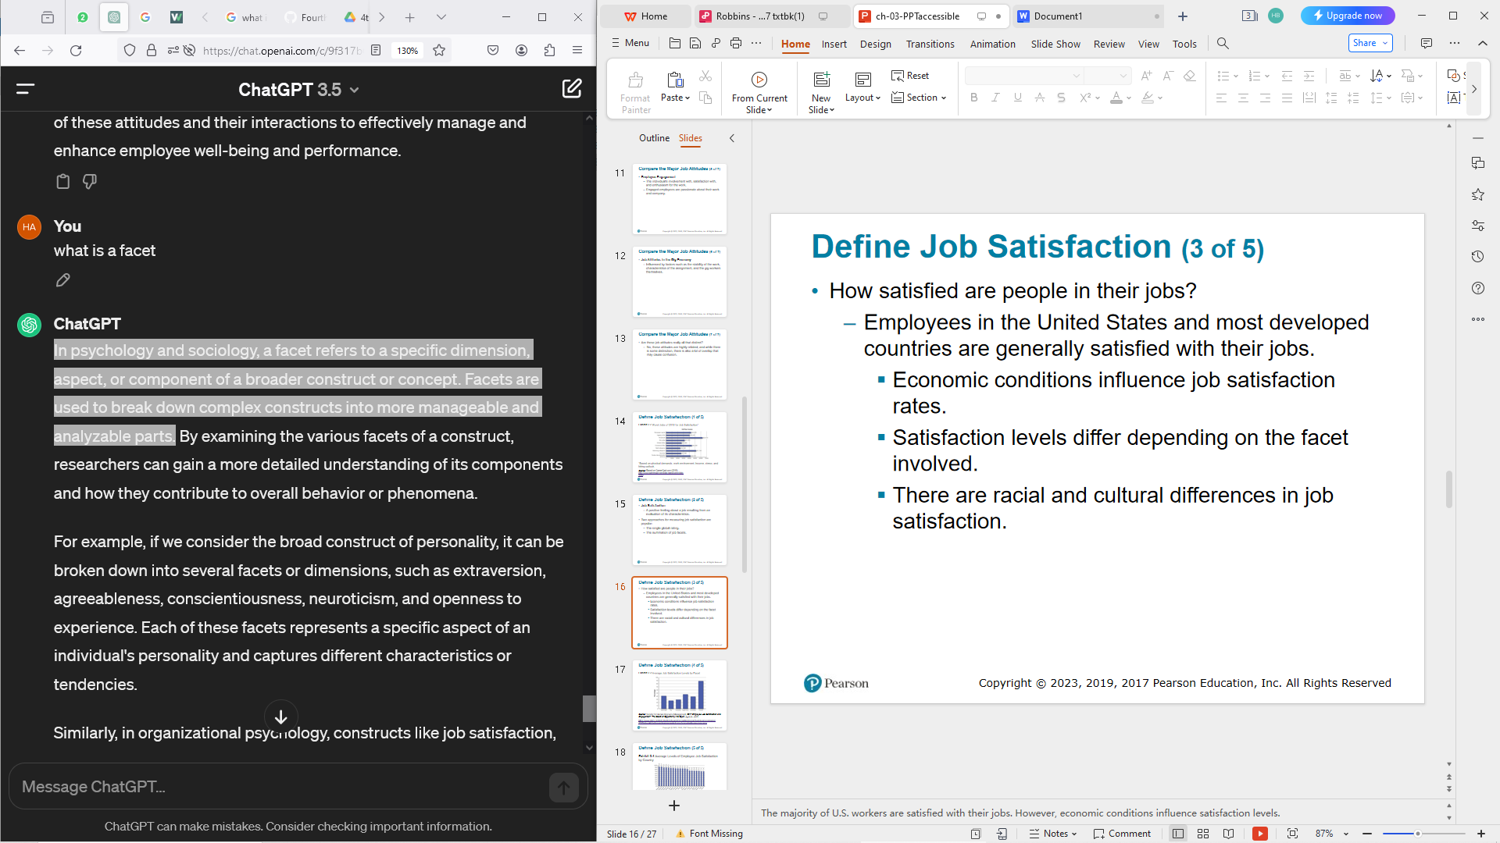

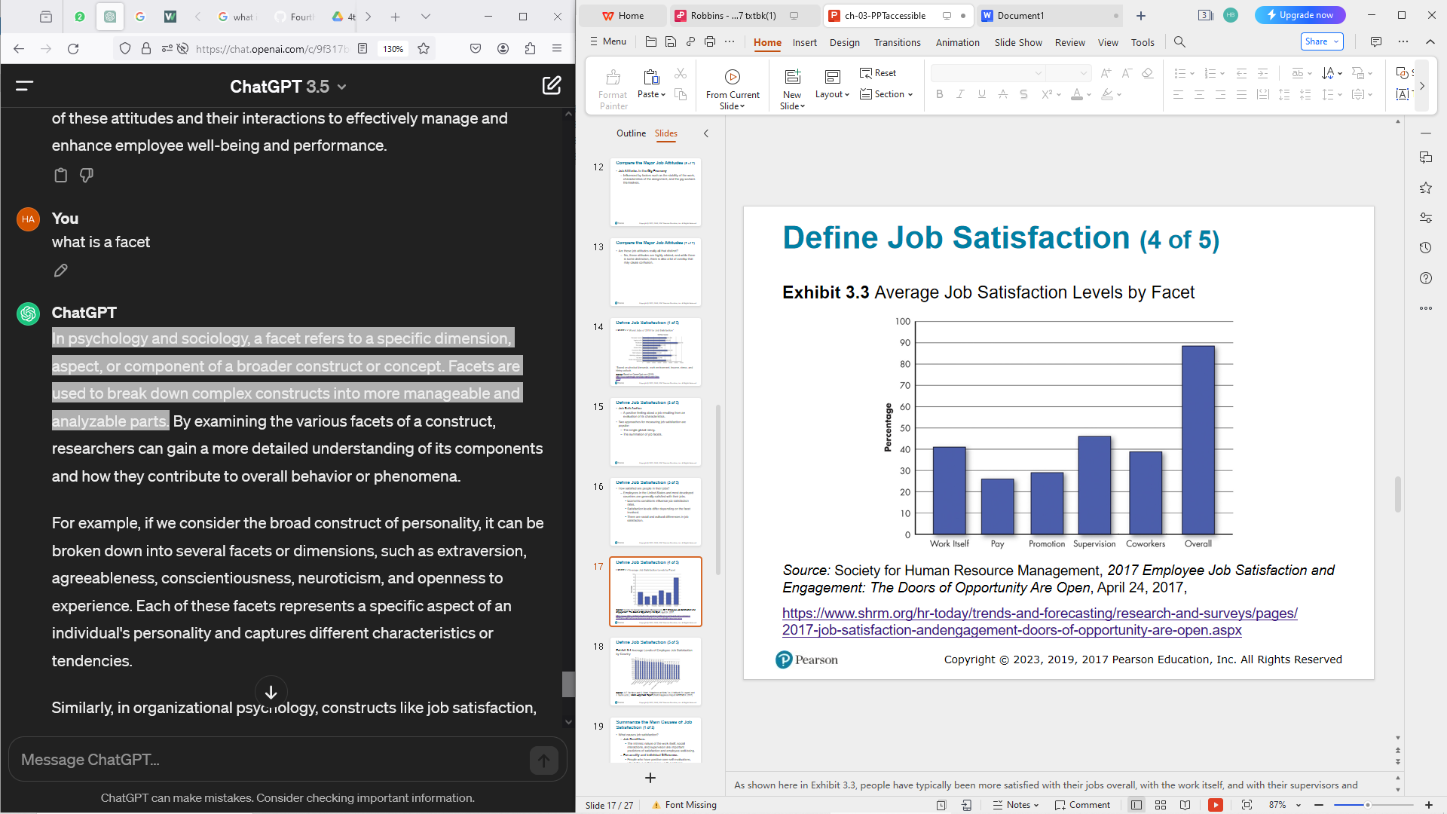

What causes job satisfaction?

-Job Conditions

The intrinsic nature of the work itself, social interactions, and supervision are important predictors of satisfaction and employee well-being.

**-Personality and Individual Differences**

People who have positive core self-evaluations, who believe in their inner worth and basic competence, are more satisfied with their jobs than those with negative core self-evaluations.

-Pay

Outcomes of Job Satisfaction

**Job Performance**

Happy workers are more likely to be productive workers.

**O C B(Organizational Citizenship Behavior)**

People who are more satisfied with their jobs are more likely to engage in

O C B.

**Customer Satisfaction**

Satisfied employees increase customer satisfaction and loyalty.

**Life Satisfaction**

Research shows that job satisfaction is positively correlated with life satisfaction.

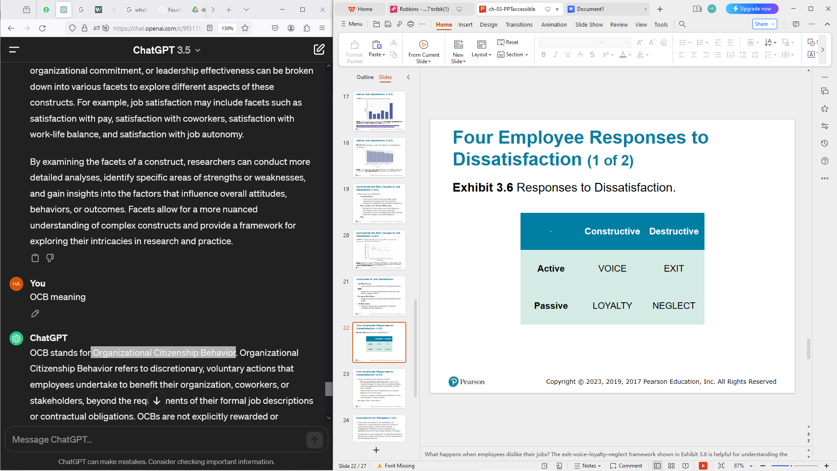

**Counterproductive Work Behavior (C W B)**

-Counterproductive work behavior: actions that actively damage the organization, including stealing, behaving aggressively toward coworkers, or being late or absent.

-Absenteeism: the more satisfied you are, the less likely you are to miss work.

-Turnover: a pattern of lowered job satisfaction is the best predictor of intent to leave.

* Managers Often “Don’t Get It”

**Implications of a Manager**

* Of the major job attitudes—job satisfaction, job involvement, organizational commitment, perceived organizational support (P O S), and employee engagement—remember that an employee’s job satisfaction level is the best single predictor of behavior.
* Pay attention to your employees’ job satisfaction levels as determinants of their performance, turnover, absenteeism, and withdrawal behaviors.
* Measure employee job attitudes objectively and at regular intervals to determine how employees are reacting to their work.
* To raise employee satisfaction, evaluate the fit between the employee’s work interests and the intrinsic parts of the job; then create work that is challenging and interesting to the individual.
* Consider the fact that high pay alone is unlikely to create a satisfying work environment.

**QUESTIONS**

**Q.How is the growth of the Gig Economy changing the way we think about organizational identification and job attitudes? Do you think companies need to do more to support and engage with gig workers?**

The growth of the Gig Economy has indeed shifted the landscape of organizational identification and job attitudes in several ways:

1.Reduced Organizational Identification: Gig workers, by nature of their transient and often independent status, may have weaker ties to any single organization compared to traditional employees. They may not feel the same sense of belonging or loyalty to a specific company, which can impact organizational identification.

2.Shift in Job Attitudes: Gig workers may have different job attitudes compared to traditional employees. Their focus may be more on autonomy, flexibility, and variety of work rather than long-term career progression or organizational commitment.

3. Importance of Individual Branding: Gig workers often rely on building their own personal brand and reputation to attract clients or gigs. This can shift the focus from organizational identification to self-identification and may influence job attitudes accordingly.

4. Challenges in Social Support: Gig workers may lack the social support networks that traditional employees enjoy within organizations. They may miss out on opportunities for mentorship, camaraderie with coworkers, and access to organizational resources for professional development.

Given these shifts, companies indeed need to do more to support and engage with gig workers:

1. Offer Training and Development: Companies can provide training and development opportunities tailored to gig workers to help them enhance their skills and stay competitive in the gig economy.

2. Facilitate Networking: Companies can create platforms or networks where gig workers can connect with each other, share experiences, and seek advice or support.

3. Provide Access to Resources: Companies can offer gig workers access to resources such as technology tools, workspace facilities, or professional networks to help them perform their work more effectively.

4. Recognize and Reward Contributions: Companies can implement recognition programs to acknowledge the contributions of gig workers and show appreciation for their efforts.

5. Offer Flexible Arrangements: Companies can adopt flexible arrangements that accommodate the needs and preferences of gig workers, such as allowing them to choose their own schedules or work remotely.

By taking proactive steps to support and engage with gig workers, companies can foster positive job attitudes and organizational identification among this growing segment of the workforce. This can lead to mutual benefits for both gig workers and the companies they collaborate with.

**Q.The COVID-19 pandemic forced many people to switch to a remote workplace. How did this change affect job satisfaction? What do you think will happen as employees return to in-person work environments?**

The shift to remote work during the COVID-19 pandemic had a mixed impact on job satisfaction, with outcomes varying depending on individual circumstances and preferences. Here are some ways in which the remote work transition affected job satisfaction:

1. Flexibility and Autonomy: Many employees appreciated the flexibility and autonomy that remote work offered, such as the ability to set their own schedules and work from the comfort of their homes. For some, this increased sense of control over their work environment contributed to higher job satisfaction.

2. Work-Life Balance: Remote work eliminated commuting time and provided more opportunities for employees to balance their work and personal lives. This improved work-life balance positively impacted job satisfaction for many individuals.

3. Reduced Stress: Some employees experienced reduced stress levels associated with the traditional office environment, such as office politics, long commutes, and distractions. This decrease in stress contributed to higher job satisfaction for these individuals.

4. Social Isolation: However, remote work also led to feelings of social isolation and loneliness for many employees, particularly those who thrived on social interactions in the workplace. The lack of face-to-face contact with colleagues and the blurring of boundaries between work and personal life negatively impacted job satisfaction for some individuals.

5. Technology Challenges: The transition to remote work also presented technological challenges for some employees, such as internet connectivity issues, difficulty collaborating with coworkers virtually, and adapting to new digital tools. These challenges could decrease job satisfaction for those who struggled to navigate remote work technology.

As employees return to in-person work environments post-pandemic, there are several potential outcomes:

1.Mixed Feelings: Some employees may feel relieved to return to the office and resume in-person interactions with colleagues, while others may be reluctant to give up the flexibility and comforts of remote work.

2. Reestablishment of Social Connections: Returning to the office can provide opportunities for employees to reconnect with coworkers and rebuild social connections, which may positively impact job satisfaction for those who missed the social aspects of the workplace.

3. Adjustment Challenges: However, there may also be challenges associated with readjusting to in-person work environments, such as commuting stress, reestablishing work-life boundaries, and adapting to changes in office dynamics.

4. Hybrid Work Models: Many organizations are adopting hybrid work models that combine remote and in-person work, offering employees the flexibility to choose where and when they work. This approach may help accommodate diverse preferences and contribute to higher job satisfaction overall.

Overall, the return to in-person work environments is likely to have a nuanced impact on job satisfaction, with individual experiences varying based on personal preferences, job roles, and organizational culture. Employers can support their employees during this transition by providing clear communication, flexibility, and opportunities for feedback and adjustment.

**Q.Some companies are allowing employees to continue to work remotely if they choose to do so. Why do you think companies are making this decision? What does it tell you about creating a satisfying work environment?**

Companies are allowing employees to continue working remotely for several reasons:

1. Employee Preferences: Many employees have expressed a desire to continue working remotely due to the flexibility and convenience it offers. Allowing remote work gives employees the autonomy to choose a work environment that best suits their needs and preferences.

2. Talent Retention: Offering remote work options can help companies retain top talent by providing flexibility and accommodating employees' work-life balance preferences. This can reduce turnover and the associated costs of recruiting and training new employees.

3. Productivity and Performance: Some companies have found that employees are just as productive, if not more so, when working remotely. By allowing remote work, companies can maintain or even improve productivity levels while reducing overhead costs associated with maintaining office spaces.

4. Geographical Diversity: Remote work allows companies to access a broader talent pool by hiring employees from different geographical locations. This can lead to a more diverse and inclusive workforce, bringing in new perspectives and ideas.

5. Cost Savings: Allowing remote work can result in cost savings for companies by reducing expenses related to office space, utilities, and other overhead costs. This can contribute to improved financial performance and profitability.

6. Resilience and Adaptability: The COVID-19 pandemic has highlighted the importance of resilience and adaptability in the face of unforeseen challenges. Companies that embrace remote work demonstrate their ability to adapt to changing circumstances and prioritize the well-being of their employees.

Allowing employees to continue working remotely reflects a shift towards creating a satisfying work environment that prioritizes flexibility, autonomy, and employee well-being. It signals that companies are listening to their employees' preferences and adapting their policies and practices accordingly. Creating a satisfying work environment involves understanding and accommodating employees' needs, fostering a culture of trust and flexibility, and promoting work-life balance. By offering remote work options, companies can create a more inclusive, supportive, and satisfying work environment that contributes to employee engagement, retention, and overall organizational success.